A Project Report

*on*

MOBILE AND ACCESSORIES SHOPEE MANAGEMENT

*By*

SOMYA ANCHALIA (T120368627)

ROHAN WADE (T120368637)

SAURABH SHETE (T120368620)

*Under the guidance of*

Dr. S. N. Gujar



Department of Information Technology

Smt. Kashibai Navale College of Engineering, Pune-41

*Accredited by NBA*

**SAVITRIBAI PHULE PUNE UNIVERSITY**

**2016-2017**

|  |  |
| --- | --- |
| Sinhgad Technical Education Society,  Department of Information Technology  Smt. Kashibai Navale College of Engineering , Pune-41 |  |

Date:

**CERTIFICATE**

This is to certify that,

SOMYA ANCHALIA (T120368627)

ROHAN WADE (T120368637)

SAURABH SHETE (T120368620)

of class T.E IT; have successfully completed their project work on “MOBILE AND ACCESSORIES SHOPEE MANAGEMENT’’ at Smt. Kashibai Navale College of Engineering, Pune in the partial fulfillment of the Graduate Degree course in T.E at the department of **Information Technology**, in the academic Year 2016-2017 Semester – I as prescribed by the University of Pune.

Dr. S. N. Gujar Prof. R.H.Borhade

Guide Head of the Department

(Department of Information Technology)

**Acknowledgements**

Acknowledgements should be in the same order of hierarchy- your guide, head of department, principal, management, lab attendants, friends and family. For acknowledgement to every category, use separate paragraphs. This may take 1 or 2 pages- if it exceeds one page, then, it is to be printed back to back. That means, in one paper, acknowledgement should be given.

Always apply ‘justify’ in every paragraph you write in your report.

SOMYA ANCHALIA (T120368627)

ROHAN WADE (T120368637)

SAURABH SHETE (T120368620)

**Contents**

|  |  |  |  |
| --- | --- | --- | --- |
| **Sr. No.** | **Topic** | | **Page No.** |
|  | **Acknowledgement** | | i |
|  | **Contents** | | ii |
|  | **List of Tables/Collections** | | iii |
|  | **List of Forms** | | iv |
|  | **Acronyms** | | v |
|  | **Abstract** | | vi |
| **Chapter-1** | **Introduction** | | 1 |
|  | 1.1 | Motivation | 1 |
|  | 1.2 | Problem Statement | 2 |
|  | 1.3 | Framework of the proposed work in project | 3 |
| **Chapter-2** | **Literature Review** | | 4 |
|  | 2.1 | Introduction | 4 |
|  | 2.2 | Existing methodologies | 5 |
|  | 2.3 | Proposed methodologies | 6 |
| **Chapter-3** | **Software Requirement Specification** | | 7 |
|  | 3.1 | Hardware Requirements | 7 |
|  | 3.2 | Software Requirements | 8 |
| **Chapter-5** | **Assumptions** | | 9 |
| **Chapter-6** | **Entity-Relationship Diagram** | | 10 |
| **Chapter-7** | **Collections** | | 11 |
| **Chapter-8** | **Forms** | | 15 |
| **Chapter-9** | **Features** | | 25 |
| **Chapter-10** | **Conclusion** | | 30 |
|  | **References** | | 31 |

**List of Tables**

|  |  |  |  |  |
| --- | --- | --- | --- | --- |
| **Table No.** | | **Title** | | **Page No** |
|  | | Basic Information of Accessories | 17-19 |
|  | | Basic Information of all devices | 17-19 |
|  | | Basic Information of all Employees | 17-19 |
| 6.4  6.5  6.6  6.7  6.8  6.9  6.10  6.11  6.12 | | Calculation of Margin  Login Information of Administrator  Name of Cities  Basic Information of all Customers  Login Information of Employee  Basic Information of Mobiles  Information about damaged android phones  Information about damaged apple phones  Information about customers having damaged phones | 17-19  17-19  17-19  17-19  17-19  17-19  17-19  17-19  17-19 |

**List of Forms**

|  |  |  |  |  |
| --- | --- | --- | --- | --- |
| **Figure No.** | **Title** | **Page**  **No** |  |  |
| 1.1 | Form to add device | 20 |  |  |
| 1.2 | Form to add employee | 21 |  |  |
| 1.3 | Admin Page Form | 21 |  |  |
| 1.4 | Forgot Password Form | 22 |  |  |
| 1.5 | Admin_ID Form | 22 |  |  |
| 1.6 | Admin Login Form | 23 |
| 1.7 | Admin Forget Password | 23 |
| 1.8 | Admin Login | 24 |
| 1.9 | Create Bill | 24 |
| 1.10 | Customer Info | 25 |
| 1.11 | Employee Page Form | 25 |
| 1.12 | Employee Forget Password | 26 |
| 1.13 | Employee_ID Form | 26 |
| 1.14 | Employee Login Form | 27 |
| 1.15 | Login Form | 27\ |
| 1.16 | Add Margin Form | 28 |
| 1.17 | View Margin Form | 28 |
| 1.18 | Modify Margin Form | 29 |
| 1.19 | Print Bill Form | 29 |
| 1.20 | Add damaged mobile Form | 30 |
| 1.21 | SPLASH Form | 30 |
| 1.22 | View Bill Form | 31 |
| 1.23 | View device Form | 31 |
| 1.24 | View employee Form | 32 |
| 1.25 | View damaged phones Form | 32 |

**Acronyms**

bno Bill Number

CName Customer Name

C_ID Customer Id

CMobile Customer’s Mobile Number

CCity City of Customer

CAddress Address of Customer

DOB Date Of Birth

Emp Employee

**Abstract**

The Mobile Store Management System is software which can become the backbone for a billing and inventory system for small organizations. This software provides an uncomplicated system to run mobile stores. This application could be very useful to small organizations. This application is inspired from current pen and paper based store management systems. It will provide an easy and attractive interface so that the user can easily manage and utilize the application. Various other approaches were considered for this application. This application is designed in a way that it will only require a minimum amount of information from the user. The goal was to look for the minimum amount of information that will meet needed requirements.

Also this system is useful for Administration Department of the shop in order to keep the track of their Employees. Also this system is very useful for the employees working in the store for keeping track of the stocks left in the store.

Chapter 1

**Introduction**

* 1. **Motivation**

An average company will not be very keen on spending loads of money on ledgers

Whereas this project will greatly reduce the costs which is using common and cheap office items like database and desktop application.

* 1. **Problem statement**

-To develop a software for Mobile store.

This system includes the following:

1. To provide a user-friendly interface for the Employees to maintain different data regarding store.
2. A secured way for the management to login with the specified username and password provided to them and an option of “Forgot password?”.
3. Different options for the management in topics like adding, deleting and updating products, keeping track of stock in the shop and transaction details of all the customers.

**1.3 Framework of proposed work in project**

The software will work on single system. The Management would have to access the software through this system. Administrator can login to the system by entering their username and password.

This system will help the Employees of the store foe keeping track of various records related to store. This will also help Administration team of the store to keep the tracks of their customers and also they will be able to view the profit of their store.

Chapter 2

**Literature review**

**2.1 Introduction**

The Mobile Store Management System is developed for desktop systems to facilitate mobile shop owners’ management of customer details and inventory data, which will include mobile phones and accessories. It can be used efficiently for physically separated shops in different locations.

This software will provide in a simple and easy to operate user interface, which can be managed by any user without having prior in-depth knowledge of the computer system. One can use this software to get a sales report.This software is a complete package for small organizations which will allow them to keep track of their sales and inventory, and provide a computerized billing system. There are various applications with more complex implementation and features available in the market, but they are generally very expensive.

Therefore, creating an application with the basic requirement of low cost is essential for small organizations. This application will allow stores to manage customer details, keep inventory of all products and purchase information, in a very simple way, using a state-of the-art software application. It will automatically generate invoices and update inventory.

**2.2 Existing methodologies**

Following are the existing methodologies:

* Traditional RDBMS System.
* Difficulties in updating data in RDBMS.
* The administrator has to perform various complex tasks manually for maintaining the whole database.

**2.3 Proposed methodologies**

Following are the proposed methodologies:

* New generation NOSQL database system MONGODB.
* Easy Updating in database structure.
* Simple User Interface.
* Auto Generation of ID’s

Chapter 3

**Software requirement specifications**

**3.1 Software requirements**

Following are the software requirements

* NetBeans IDE 6.0 or above
* JDK 5.0 or above
* Mongodb database.
* Microsoft® Windows® XP or above

**3.2 Hardware requirements**

Following are the hardware requirements

* Intel Pentium-based processor (Minimum 1.7GHz Pentium 4 Processor)
* Minimum 10GB HDD
* Minimum 512MB RAM
* Monitor
* Keyboard
* Mouse

Chapter 4

**Assumptions**

**4.1 General Assumptions**

Following are the general assumptions in the developed software:

* All the entries those are to be entered are less than the length which is already defined for

Each attribute.

* Can add/edit/delete different mobiles and accessories from the system. He can add/edit/delete new mobiles, accessories and other details.
* Can add/edit/delete users in this system. It’s the admin who add new employees account into the system.

**4.2 Assumptions for Employee**

The assumptions from the point of view of a staff member are as follows:

1. Can add/edit/delete different mobile phones and accessories.

2. Can add/edit/delete different stock items, generate bills etc.

**4.3 Assumptions for Administrator**

The assumptions from the point of view of Administrator are as follows:

1. Can add/edit/delete different Employee information.

2. Can calculate the profit margin of the shop.

Chapter 5

**E-R Diagram**

E-R model i.e. Entity Relation model is based on a perception of real world that consists of set of basic objects called entities and relationship among these objects. In the E-R diagram shown below, there are 10 entity sets. The entity sets are related to each other and are shown related to each other by a diamond. Each entity contains some attributes which are related to it. A primary key is nothing but a key chosen by a designer as the principal means of identifying entities within an entity set. A primary key is represented in an ellipse by a line under it. Cardinality of relationships is mentioned as one-to-one or one-to-many.

The E-R Diagram for the Mobile and Accessories Management is on the next page…



Chapter 6

**Tables**

Table6.1-OVERVIEW:

|  |  |
| --- | --- |
| **ENTITY** | **ATTRIBUTES** |
| Add_device | Type,Model,Price,Quantity,Specifications |
| Add_emp | Name,DOB,Adharno,Mobileno,Address |
| Add_margin | Type,Model,Costprice,Sellingprice,Margin |
| Admin | Username,Password,Hint |
| Customer_ info | Date,Type,Model,Price,Quantity,Cname,CMobile,CAddress,CCity,Total,Billno |  |  |  |  |  | **CMobile** | **CAddress** | **CCity** | **Total** |
| Repair_mobile | C_ID,Name,Type,Model,Price,Query,Status |
| Mob_repair | Type,Phone |

Table 6.2 Add_device:

|  |  |  |  |  |
| --- | --- | --- | --- | --- |
| **Type** | **Model** | **Price** | **Quantity** | **Specifications** |
| Mobile | Moto g2 | 25000 | 4 | 3GB Ram |

Table 6.3 Add_emp:

|  |  |  |  |  |
| --- | --- | --- | --- | --- |
| **Name** | **DOB** | **Adhar no** | **Mobileno** | **Address** |
| Somya | 17-06-2016 | 123456789012 | 9765413984 | Pune |

Table 6.4 Add_margin:

|  |  |  |  |  |
| --- | --- | --- | --- | --- |
| **Type** | **Model** | **Cost price** | **Selling price** | **margin** |
| Mobile | Moto g3 | 10000 | 13000 | 3000 |

Table 6.5 Admin:

|  |  |  |
| --- | --- | --- |
| **Username** | **Password** | **Hint** |
| Saurabh | Saurabh | Name |

Table 6.6 Customer_nfo:

|  |  |  |  |  |  |  |  |  |  |  |
| --- | --- | --- | --- | --- | --- | --- | --- | --- | --- | --- |
| **Date** | **Type** | **Model** | **Price** | **Qua** | **CName** | **CMobile** | **CAddress** | **CCity** | **Total** | **Billno** |
| 4-10-2016 | Mobile | Moto g4 | 15000 | 4 | Aaa | 9763490085 | pune | pune | 45000 | 572 |

Table 6.7 Repair_mobile:

|  |  |  |  |  |  |  |
| --- | --- | --- | --- | --- | --- | --- |
| **C_ID** | **Name** | **Type** | **Model** | **Price** | **Query** | **Status** |
| 1 | Rohan | Android | Moto g$ | 700 | Broken Display | N |

Table 6.8 Mob_repair:

|  |  |
| --- | --- |
| **Type** | **phone** |
| Android | Moto G |

Chapter 7

**Forms**

SCREENSHOTS

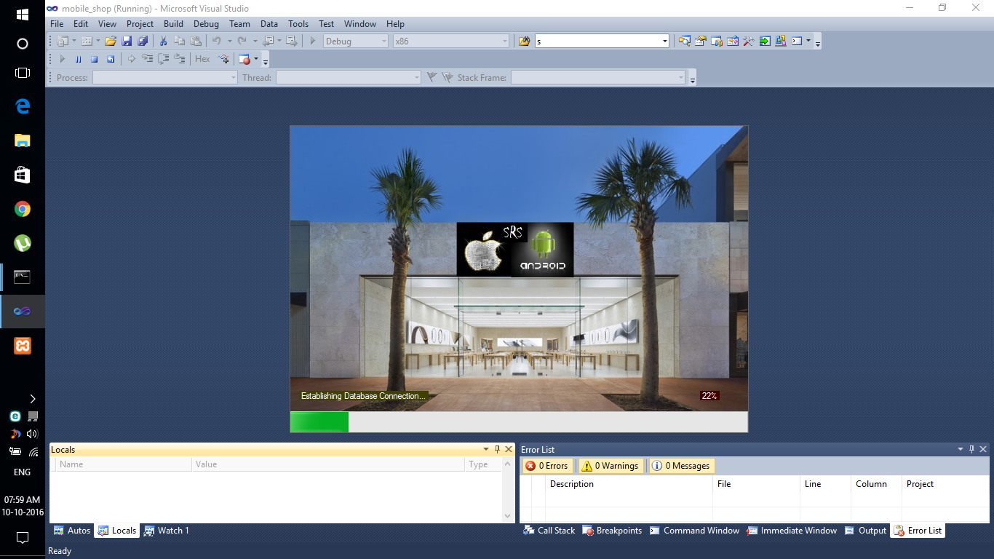

It is displayed at the execution of the software.

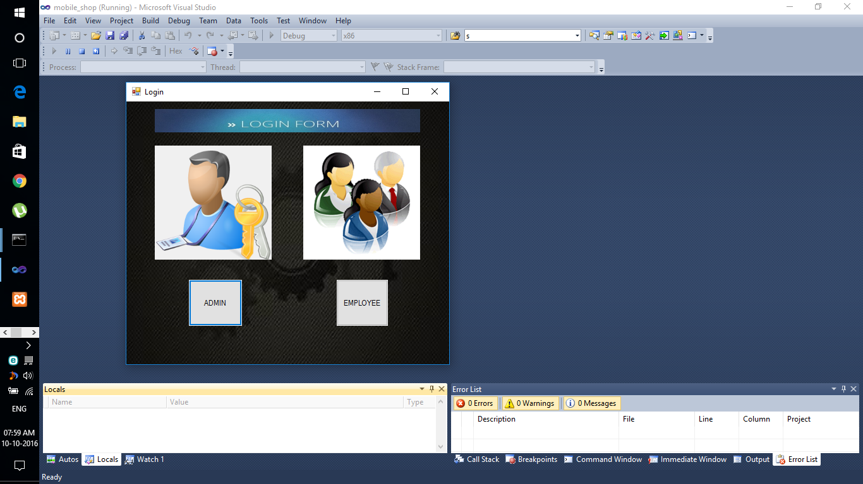

This is used to select the Admin or Employee

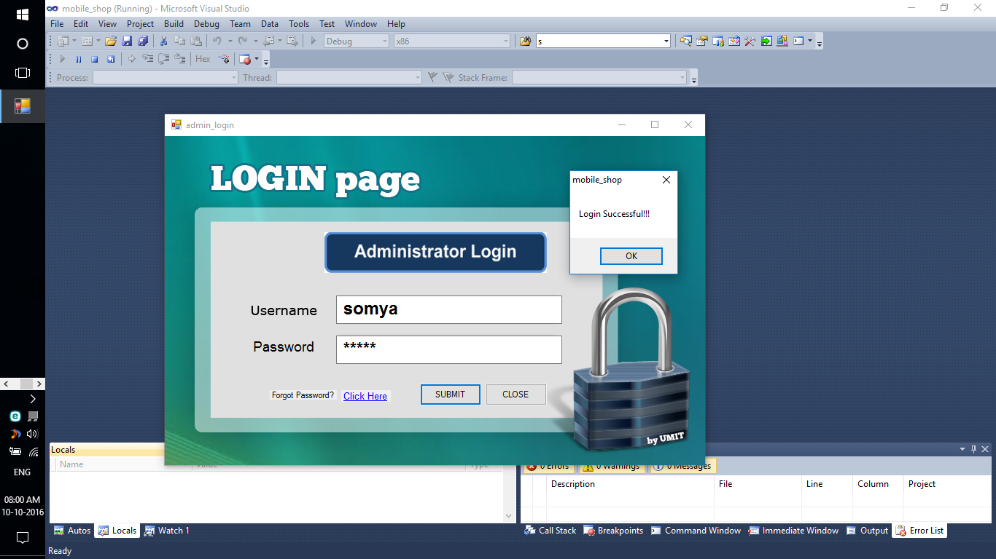

This is administrator login page

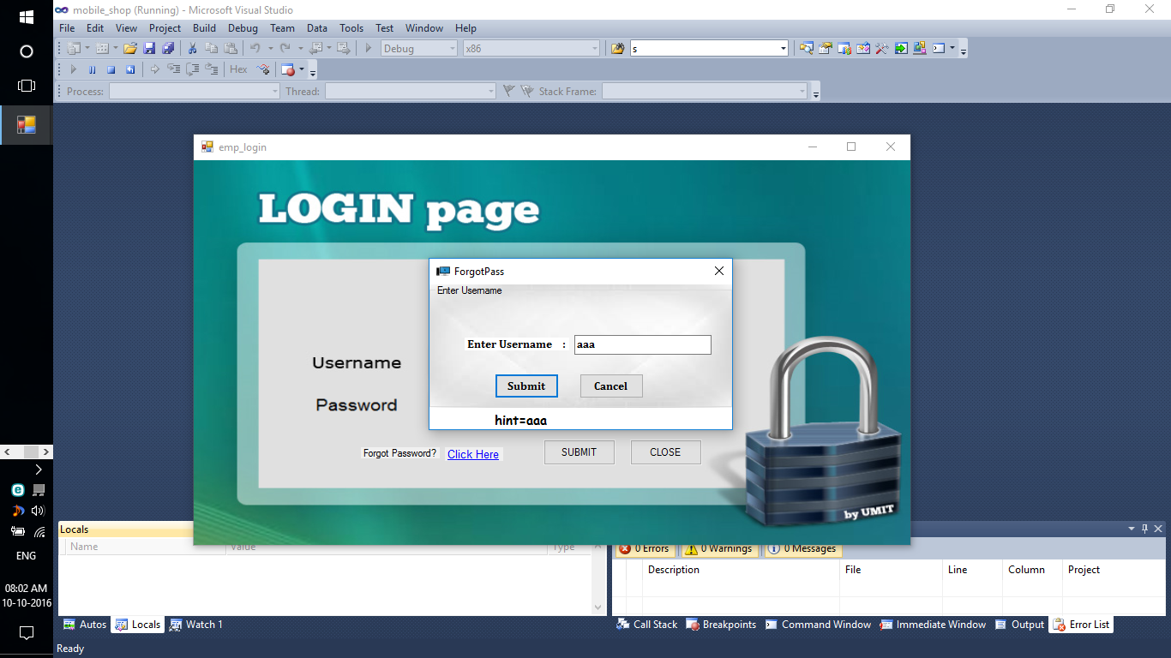

This is used for retrieving hint by giving appropriate Username

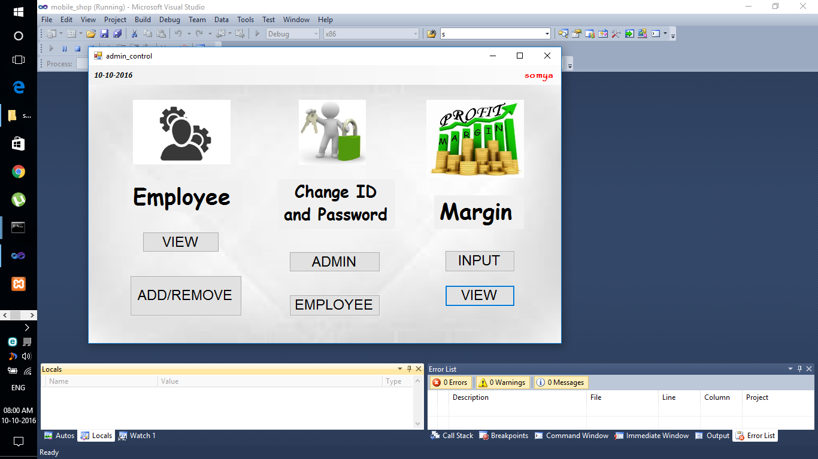

These tasks are under control of the Administrator

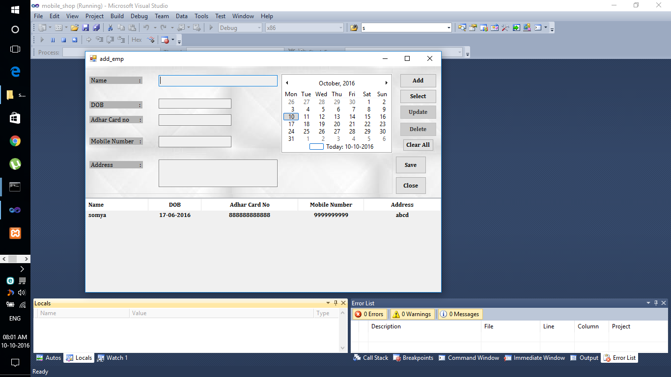

This form adds information about Employee.

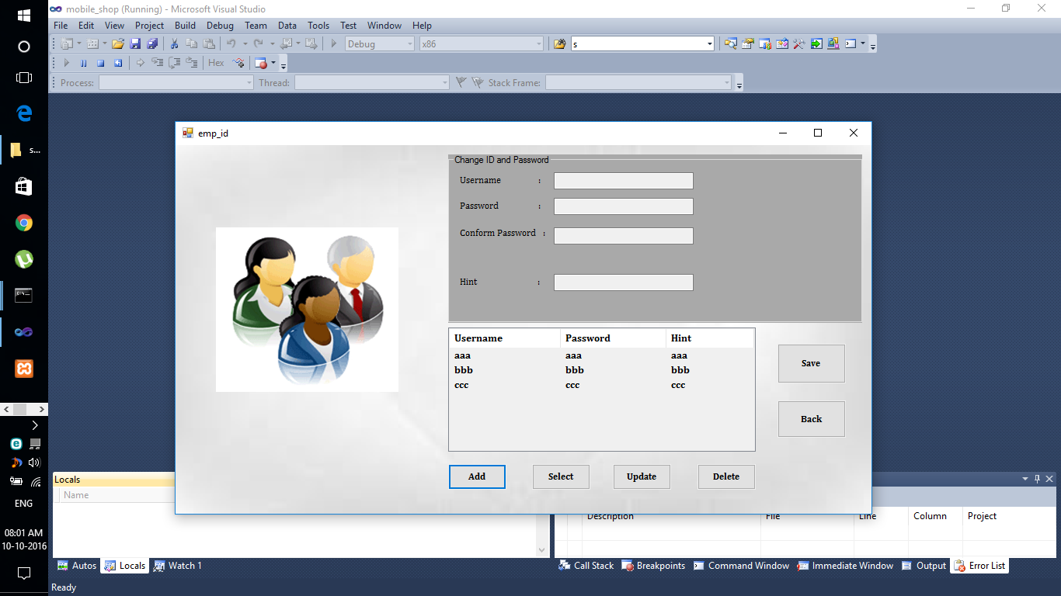

This is form changes Login Id and Password for Employee

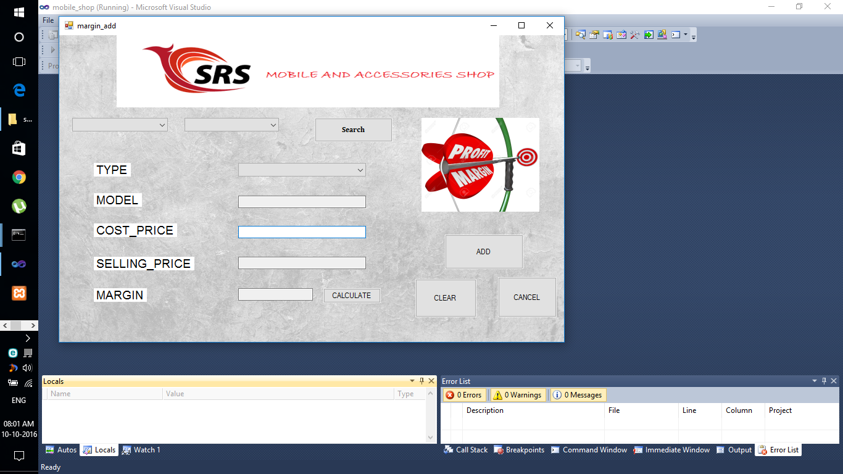

This form calculates Profit Margin for the shop.

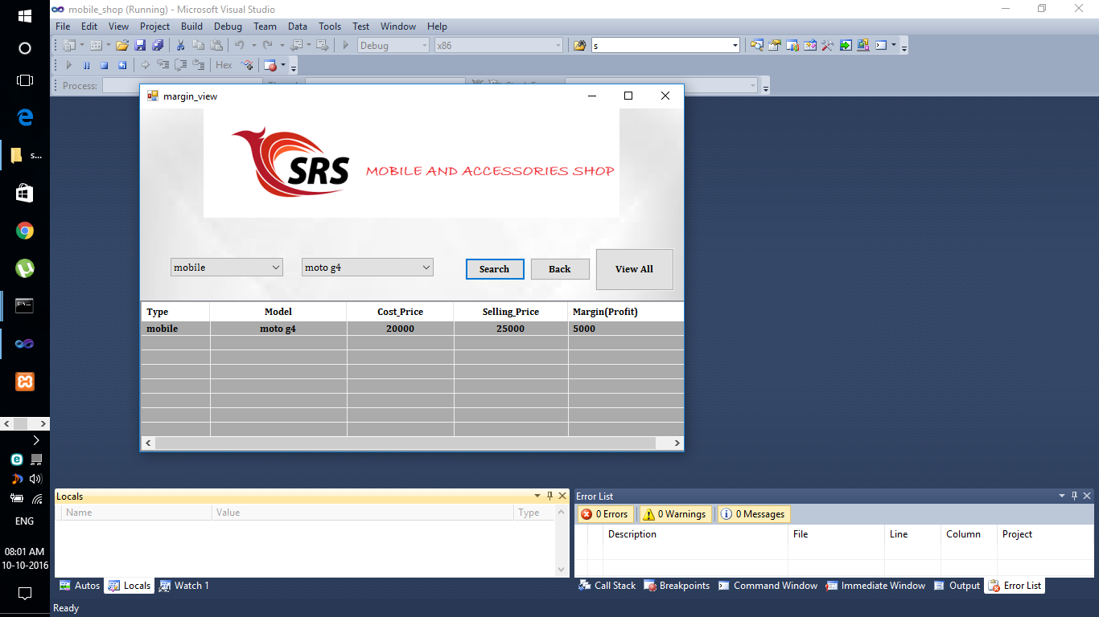

This form shows information regarding Profit/Margin for the shop

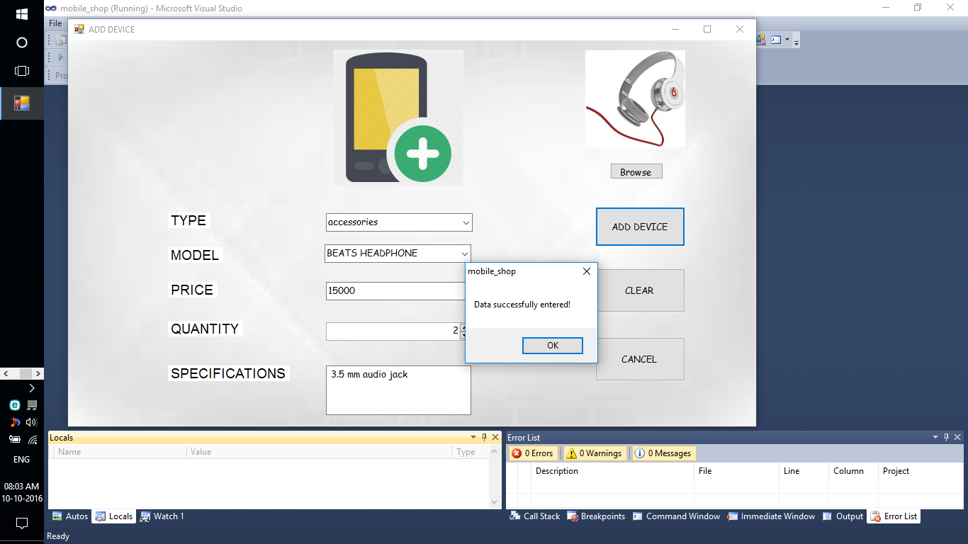

This form is used for adding new devices in the shop.

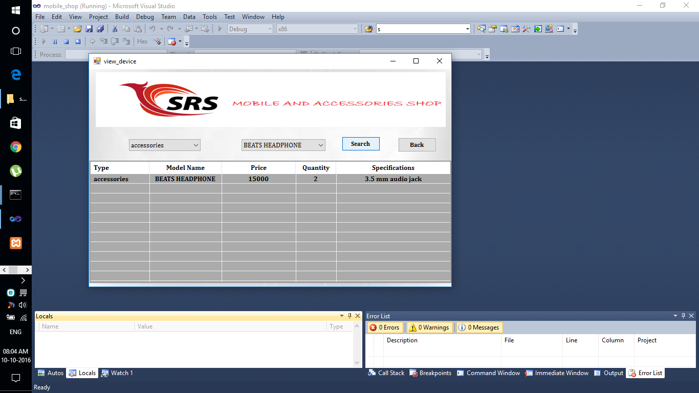

This form displays all information of a device in the shop.

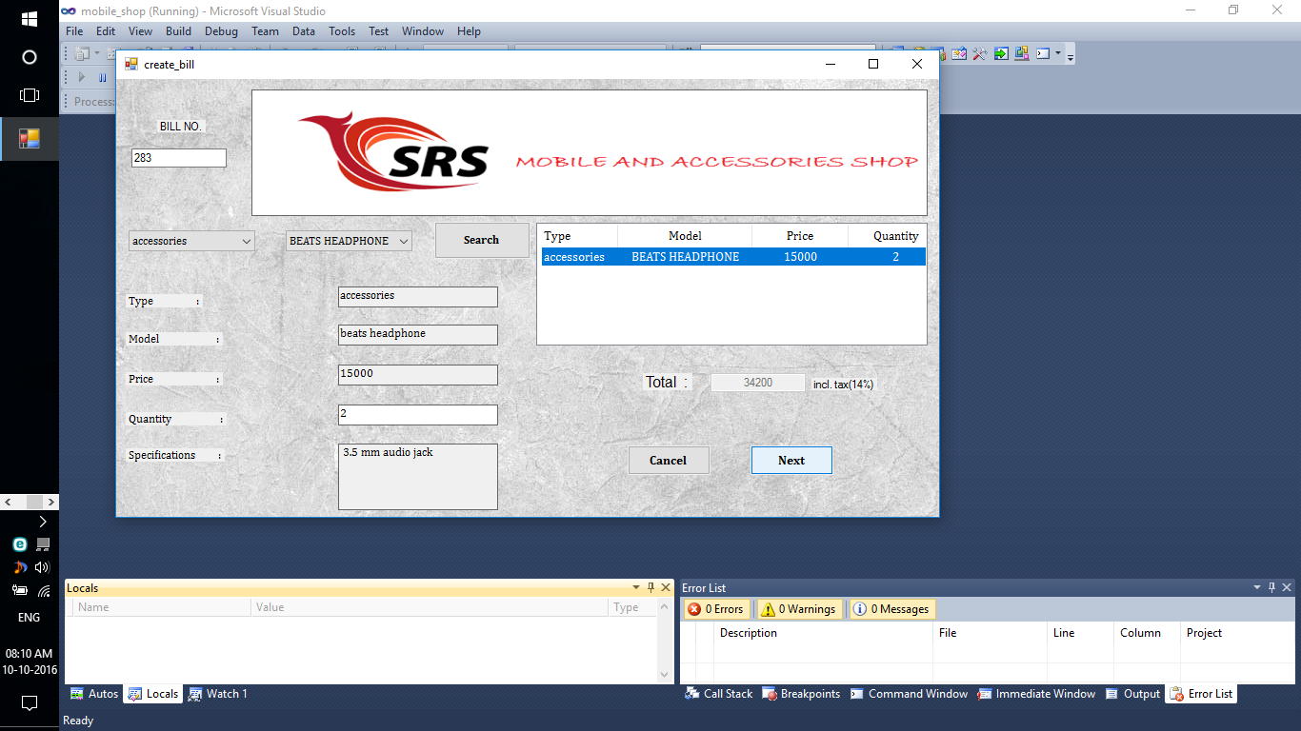

This form is used for creating bills for the customers. In this form the bill number is automatically generated.

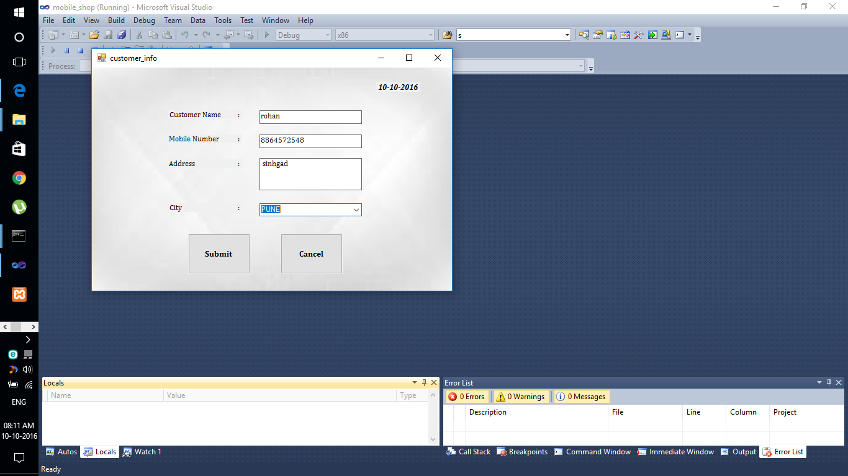

This form is used for filling information of customer for generating bill.

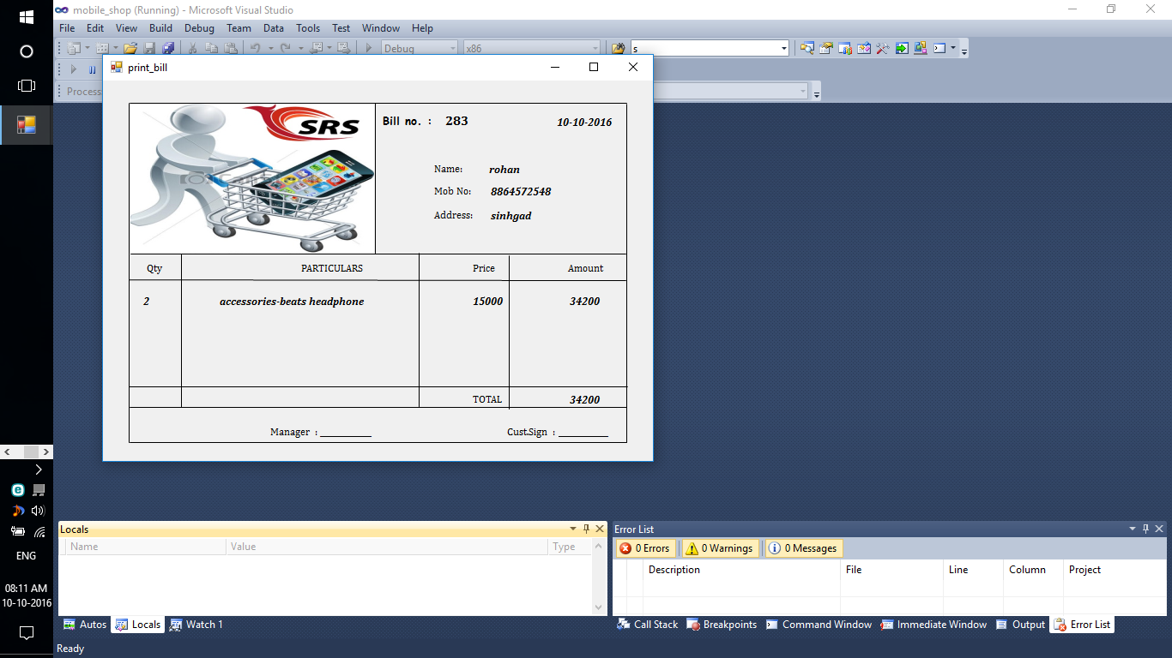

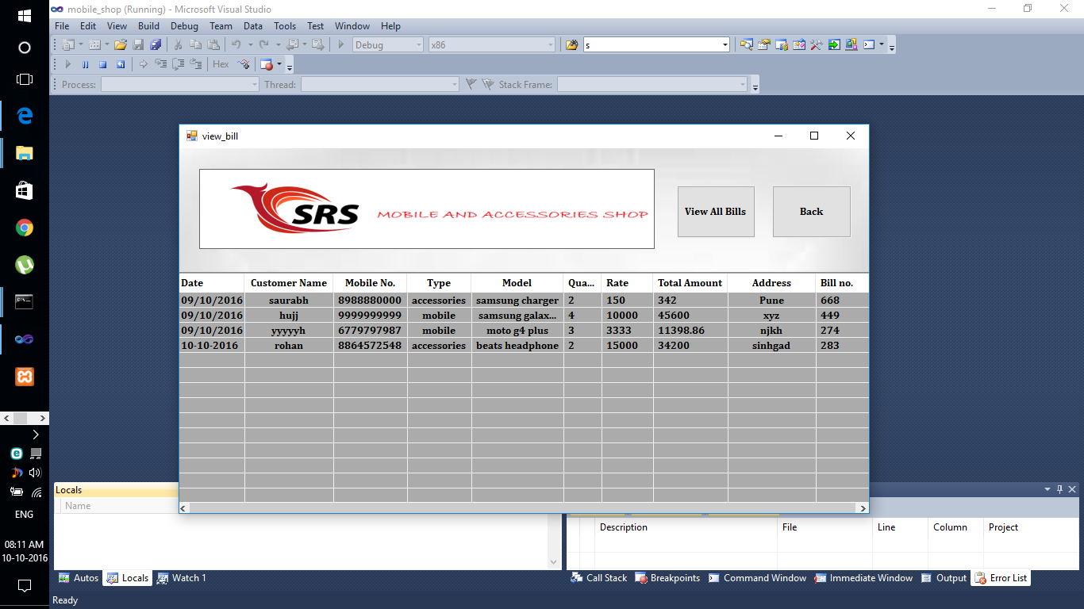 This is the actual bill which is printed

This form is used for viewing all the information of the bills.

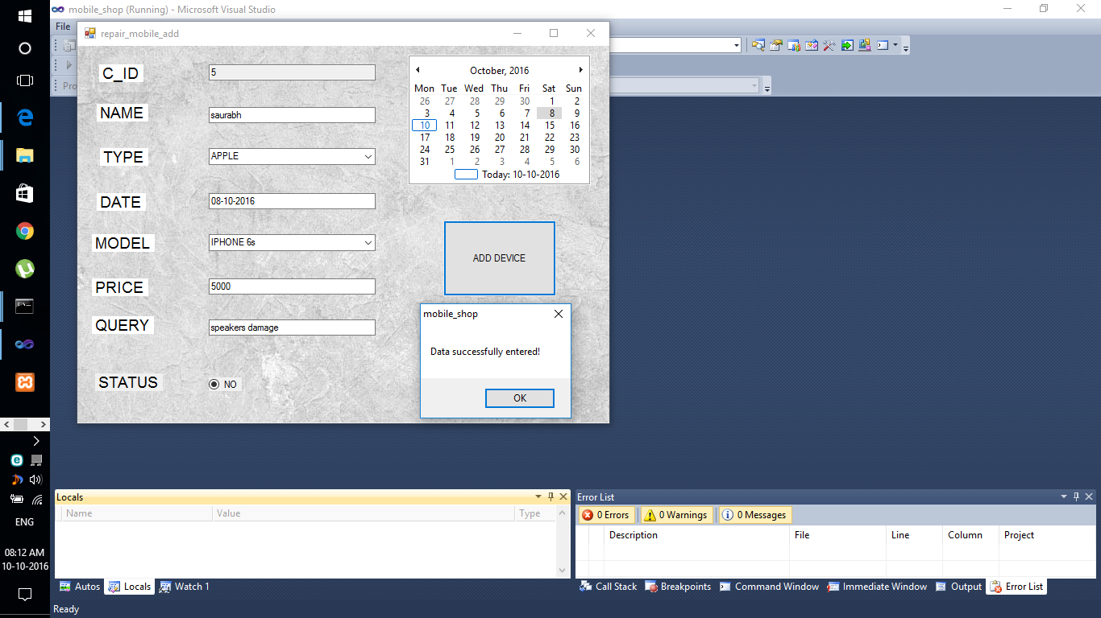

This form is used to add information about the damaged devices of customers.

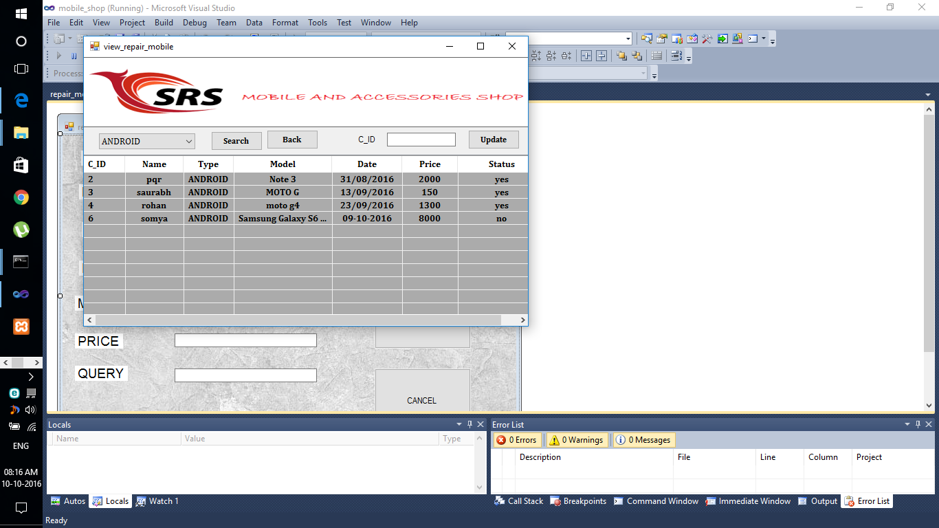

This form displays information regarding damaged phones and also it show its repair status.

Chapter 8

**Features**

The software developed is a distributed database system. Various terminals are located at multiple locations in the resort. The users can login to the system by using any terminal and interact with the software. The prominent features of the software can be described as follows;

**8.1 Repair and Maintenance of Mobile Phones**

The repair and maintenance feature is provided for the customers having damaged phones. This feature is useful when there are some defects in the phone and the customer wants to repair it. Then the employee of the store will add the details of the faulty device in the database with the help of this software. And when the device is repaired successfully then the employee will upload the status to “Yes” saying that device is repaired and then the customer can collect his/her device.

**8.2 Comprehensive Management Database and Logs**

The software maintains a comprehensive database containing all the relevant details of every part of the mobile shop. This information in this database can be manipulated to generate various reports for the administrator. A full analysis of sales of a particular product and the profit made by it is calculated. All the bill details are also made available. Software also provides the facility for adding new items in the shop and manipulating the existing ones.Also repair and maintenance of the devices is made available to customers. This will help the customers to repair their faulty devices.

Chapter 9

**Conclusion**

Projects and solutions are at the core of any work you do with Visual Studio .NET. Projects represent individual components or applications. Solutions are collections of related projects. Solutions can manage the dependencies between projects, ensuring that components are built in the correct order and copied into the right places. Of course, a solution and its projects would be of no use at all if they didn't contain source code of some kind, so in the next chapter we will look at the features in Visual Studio .NET designed to help you edit individual files.

Chapter 10

**References**

1. [www.google.com](http://www.google.com)
2. [www.Net-tutorials.com](http://www.Net-tutorials.com)
3. <http://www.tutorialspoint.com/mongodb/>
4. Silberschatz A., Korth H., Sudarshan S., "Database System Concepts", 4th Edition, McGraw Hill Publishers

5 Agus Kurniawan,”MongoDB Succinctly”, Syncfusion.